Deskriptif

Frequency Table

X1
 |  | Frequency | Percent | Valid Percent | Cumulative Percent
Valid | 1 | 2 | 1,8 | 1,8 | 1,8
 | 2 | 6 | 5,4 | 5,4 | 7,2
 | 3 | 27 | 24,3 | 24,3 | 31,5
 | 4 | 19 | 17,1 | 17,1 | 48,6
 | 5 | 19 | 17,1 | 17,1 | 65,8
 | 6 | 14 | 12,6 | 12,6 | 78,4
 | 7 | 14 | 12,6 | 12,6 | 91,0
 | 8 | 6 | 5,4 | 5,4 | 96,4
 | 9 | 2 | 1,8 | 1,8 | 98,2
 | 10 | 2 | 1,8 | 1,8 | 100,0
 | Total | 111 | 100,0 | 100,0

X2
 |  | Frequency | Percent | Valid Percent | Cumulative Percent
Valid | 1 | 9 | 8,1 | 8,1 | 8,1
 | 2 | 15 | 13,5 | 13,5 | 21,6
 | 3 | 11 | 9,9 | 9,9 | 31,5
 | 4 | 20 | 18,0 | 18,0 | 49,5
 | 5 | 22 | 19,8 | 19,8 | 69,4
 | 6 | 15 | 13,5 | 13,5 | 82,9
 | 7 | 11 | 9,9 | 9,9 | 92,8
 | 8 | 4 | 3,6 | 3,6 | 96,4
 | 9 | 2 | 1,8 | 1,8 | 98,2
 | 10 | 2 | 1,8 | 1,8 | 100,0
 | Total | 111 | 100,0 | 100,0

X3
 |  | Frequency | Percent | Valid Percent | Cumulative Percent
Valid | 1 | 9 | 8,1 | 8,1 | 8,1
 | 2 | 22 | 19,8 | 19,8 | 27,9
 | 3 | 18 | 16,2 | 16,2 | 44,1
 | 4 | 10 | 9,0 | 9,0 | 53,2
 | 5 | 18 | 16,2 | 16,2 | 69,4
 | 6 | 19 | 17,1 | 17,1 | 86,5
 | 7 | 6 | 5,4 | 5,4 | 91,9
 | 8 | 6 | 5,4 | 5,4 | 97,3
 | 9 | 1 | ,9 | ,9 | 98,2
 | 10 | 2 | 1,8 | 1,8 | 100,0
 | Total | 111 | 100,0 | 100,0

X4
 |  | Frequency | Percent | Valid Percent | Cumulative Percent
Valid | 1 | 7 | 6,3 | 6,3 | 6,3
 | 2 | 15 | 13,5 | 13,5 | 19,8
 | 3 | 16 | 14,4 | 14,4 | 34,2
 | 4 | 20 | 18,0 | 18,0 | 52,3
 | 5 | 25 | 22,5 | 22,5 | 74,8
 | 6 | 11 | 9,9 | 9,9 | 84,7
 | 7 | 7 | 6,3 | 6,3 | 91,0
 | 8 | 5 | 4,5 | 4,5 | 95,5
 | 10 | 5 | 4,5 | 4,5 | 100,0
 | Total | 111 | 100,0 | 100,0

X5
 |  | Frequency | Percent | Valid Percent | Cumulative Percent
Valid | 1 | 3 | 2,7 | 2,7 | 2,7
 | 2 | 8 | 7,2 | 7,2 | 9,9
 | 3 | 11 | 9,9 | 9,9 | 19,8
 | 4 | 13 | 11,7 | 11,7 | 31,5
 | 5 | 19 | 17,1 | 17,1 | 48,6
 | 6 | 22 | 19,8 | 19,8 | 68,5
 | 7 | 21 | 18,9 | 18,9 | 87,4
 | 8 | 4 | 3,6 | 3,6 | 91,0
 | 9 | 5 | 4,5 | 4,5 | 95,5
 | 10 | 5 | 4,5 | 4,5 | 100,0
 | Total | 111 | 100,0 | 100,0

X6
 |  | Frequency | Percent | Valid Percent | Cumulative Percent
Valid | 1 | 4 | 3,6 | 3,6 | 3,6
 | 2 | 6 | 5,4 | 5,4 | 9,0
 | 3 | 10 | 9,0 | 9,0 | 18,0
 | 4 | 14 | 12,6 | 12,6 | 30,6
 | 5 | 19 | 17,1 | 17,1 | 47,7
 | 6 | 23 | 20,7 | 20,7 | 68,5
 | 7 | 14 | 12,6 | 12,6 | 81,1
 | 8 | 6 | 5,4 | 5,4 | 86,5
 | 9 | 7 | 6,3 | 6,3 | 92,8
 | 10 | 8 | 7,2 | 7,2 | 100,0
 | Total | 111 | 100,0 | 100,0

X7
 |  | Frequency | Percent | Valid Percent | Cumulative Percent
Valid | 1 | 2 | 1,8 | 1,8 | 1,8
 | 2 | 7 | 6,3 | 6,3 | 8,1
 | 3 | 14 | 12,6 | 12,6 | 20,7
 | 4 | 16 | 14,4 | 14,4 | 35,1
 | 5 | 14 | 12,6 | 12,6 | 47,7
 | 6 | 15 | 13,5 | 13,5 | 61,3
 | 7 | 23 | 20,7 | 20,7 | 82,0
 | 8 | 9 | 8,1 | 8,1 | 90,1
 | 9 | 7 | 6,3 | 6,3 | 96,4
 | 10 | 4 | 3,6 | 3,6 | 100,0
 | Total | 111 | 100,0 | 100,0

X8
 |  | Frequency | Percent | Valid Percent | Cumulative Percent
Valid | 1 | 1 | ,9 | ,9 | ,9
 | 2 | 5 | 4,5 | 4,5 | 5,4
 | 3 | 12 | 10,8 | 10,8 | 16,2
 | 4 | 19 | 17,1 | 17,1 | 33,3
 | 5 | 15 | 13,5 | 13,5 | 46,8
 | 6 | 24 | 21,6 | 21,6 | 68,5
 | 7 | 11 | 9,9 | 9,9 | 78,4
 | 8 | 13 | 11,7 | 11,7 | 90,1
 | 9 | 3 | 2,7 | 2,7 | 92,8
 | 10 | 8 | 7,2 | 7,2 | 100,0
 | Total | 111 | 100,0 | 100,0

X9
 |  | Frequency | Percent | Valid Percent | Cumulative Percent
Valid | 1 | 5 | 4,5 | 4,5 | 4,5
 | 2 | 4 | 3,6 | 3,6 | 8,1
 | 3 | 14 | 12,6 | 12,6 | 20,7
 | 4 | 20 | 18,0 | 18,0 | 38,7
 | 5 | 12 | 10,8 | 10,8 | 49,5
 | 6 | 23 | 20,7 | 20,7 | 70,3
 | 7 | 25 | 22,5 | 22,5 | 92,8
 | 8 | 3 | 2,7 | 2,7 | 95,5
 | 9 | 3 | 2,7 | 2,7 | 98,2
 | 10 | 2 | 1,8 | 1,8 | 100,0
 | Total | 111 | 100,0 | 100,0

X10
 |  | Frequency | Percent | Valid Percent | Cumulative Percent
Valid | 1 | 1 | ,9 | ,9 | ,9
 | 2 | 3 | 2,7 | 2,7 | 3,6
 | 3 | 20 | 18,0 | 18,0 | 21,6
 | 4 | 15 | 13,5 | 13,5 | 35,1
 | 5 | 13 | 11,7 | 11,7 | 46,8
 | 6 | 15 | 13,5 | 13,5 | 60,4
 | 7 | 25 | 22,5 | 22,5 | 82,9
 | 8 | 10 | 9,0 | 9,0 | 91,9
 | 9 | 7 | 6,3 | 6,3 | 98,2
 | 10 | 2 | 1,8 | 1,8 | 100,0
 | Total | 111 | 100,0 | 100,0

X11
 |  | Frequency | Percent | Valid Percent | Cumulative Percent
Valid | 1 | 6 | 5,4 | 5,4 | 5,4
 | 2 | 4 | 3,6 | 3,6 | 9,0
 | 3 | 10 | 9,0 | 9,0 | 18,0
 | 4 | 19 | 17,1 | 17,1 | 35,1
 | 5 | 12 | 10,8 | 10,8 | 45,9
 | 6 | 11 | 9,9 | 9,9 | 55,9
 | 7 | 16 | 14,4 | 14,4 | 70,3
 | 8 | 18 | 16,2 | 16,2 | 86,5
 | 9 | 13 | 11,7 | 11,7 | 98,2
 | 10 | 2 | 1,8 | 1,8 | 100,0
 | Total | 111 | 100,0 | 100,0

X12
 |  | Frequency | Percent | Valid Percent | Cumulative Percent
Valid | 1 | 3 | 2,7 | 2,7 | 2,7
 | 2 | 5 | 4,5 | 4,5 | 7,2
 | 3 | 9 | 8,1 | 8,1 | 15,3
 | 4 | 21 | 18,9 | 18,9 | 34,2
 | 5 | 13 | 11,7 | 11,7 | 45,9
 | 6 | 12 | 10,8 | 10,8 | 56,8
 | 7 | 17 | 15,3 | 15,3 | 72,1
 | 8 | 19 | 17,1 | 17,1 | 89,2
 | 9 | 10 | 9,0 | 9,0 | 98,2
 | 10 | 2 | 1,8 | 1,8 | 100,0
 | Total | 111 | 100,0 | 100,0

X13
 |  | Frequency | Percent | Valid Percent | Cumulative Percent
Valid | 1 | 4 | 3,6 | 3,6 | 3,6
 | 2 | 7 | 6,3 | 6,3 | 9,9
 | 3 | 12 | 10,8 | 10,8 | 20,7
 | 4 | 16 | 14,4 | 14,4 | 35,1
 | 5 | 12 | 10,8 | 10,8 | 45,9
 | 6 | 13 | 11,7 | 11,7 | 57,7
 | 7 | 18 | 16,2 | 16,2 | 73,9
 | 8 | 17 | 15,3 | 15,3 | 89,2
 | 9 | 11 | 9,9 | 9,9 | 99,1
 | 10 | 1 | ,9 | ,9 | 100,0
 | Total | 111 | 100,0 | 100,0

Konfirmatori Beban Kerja
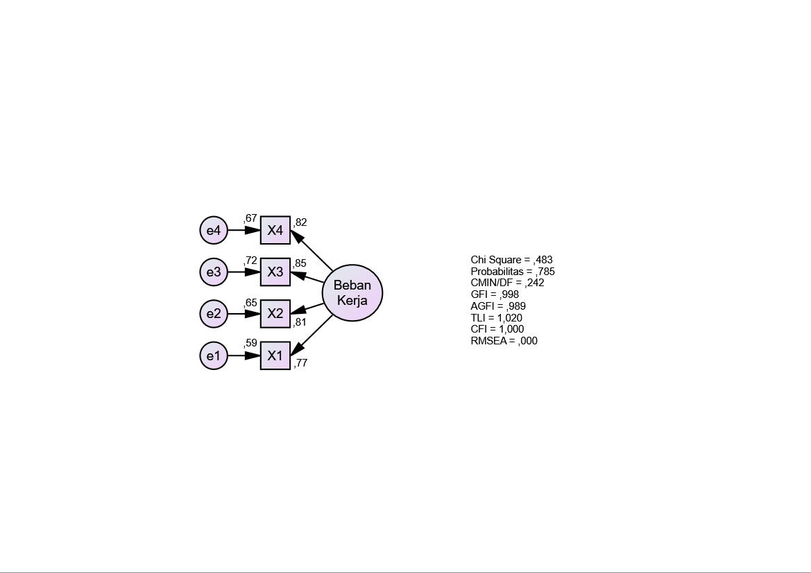

Regression Weights: (Group number 1 - Default model)
 |  |  | Estimate | S.E. | C.R. | P | Label
X1 | <--- | Beban_Kerja | 1,000
X2 | <--- | Beban_Kerja | 1,141 | ,133 | 8,554 | *** | par_1
X3 | <--- | Beban_Kerja | 1,238 | ,135 | 9,141 | *** | par_2
X4 | <--- | Beban_Kerja | 1,179 | ,135 | 8,754 | *** | par_3

Standardized Regression Weights: (Group number 1 - Default model)
 |  |  | Estimate
X1 | <--- | Beban_Kerja | ,770
X2 | <--- | Beban_Kerja | ,807
X3 | <--- | Beban_Kerja | ,850
X4 | <--- | Beban_Kerja | ,821

Model Fit Summary

CMIN
Model | NPAR | CMIN | DF | P | CMIN/DF
Default model | 8 | ,483 | 2 | ,785 | ,242
Saturated model | 10 | ,000 | 0
Independence model | 4 | 237,880 | 6 | ,000 | 39,647

RMR, GFI
Model | RMR | GFI | AGFI | PGFI
Default model | ,031 | ,998 | ,989 | ,200
Saturated model | ,000 | 1,000
Independence model | 2,234 | ,434 | ,056 | ,260

Baseline Comparisons
Model | NFI  Delta1 | RFI  rho1 | IFI  Delta2 | TLI  rho2 | CFI
Default model | ,998 | ,994 | 1,006 | 1,020 | 1,000
Saturated model | 1,000 |  | 1,000 |  | 1,000
Independence model | ,000 | ,000 | ,000 | ,000 | ,000

Parsimony-Adjusted Measures
Model | PRATIO | PNFI | PCFI
Default model | ,333 | ,333 | ,333
Saturated model | ,000 | ,000 | ,000
Independence model | 1,000 | ,000 | ,000

NCP
Model | NCP | LO 90 | HI 90
Default model | ,000 | ,000 | 3,283
Saturated model | ,000 | ,000 | ,000
Independence model | 231,880 | 185,117 | 286,062

FMIN
Model | FMIN | F0 | LO 90 | HI 90
Default model | ,004 | ,000 | ,000 | ,030
Saturated model | ,000 | ,000 | ,000 | ,000
Independence model | 2,163 | 2,108 | 1,683 | 2,601

RMSEA
Model | RMSEA | LO 90 | HI 90 | PCLOSE
Default model | ,000 | ,000 | ,122 | ,832
Independence model | ,593 | ,530 | ,658 | ,000

AIC
Model | AIC | BCC | BIC | CAIC
Default model | 16,483 | 17,245 | 38,159 | 46,159
Saturated model | 20,000 | 20,952 | 47,095 | 57,095
Independence model | 245,880 | 246,261 | 256,719 | 260,719

ECVI
Model | ECVI | LO 90 | HI 90 | MECVI
Default model | ,150 | ,164 | ,193 | ,157
Saturated model | ,182 | ,182 | ,182 | ,190
Independence model | 2,235 | 1,810 | 2,728 | 2,239

HOELTER
Model | HOELTER  .05 | HOELTER  .01
Default model | 1365 | 2097
Independence model | 6 | 8

Konfirmatori Stress Kerja
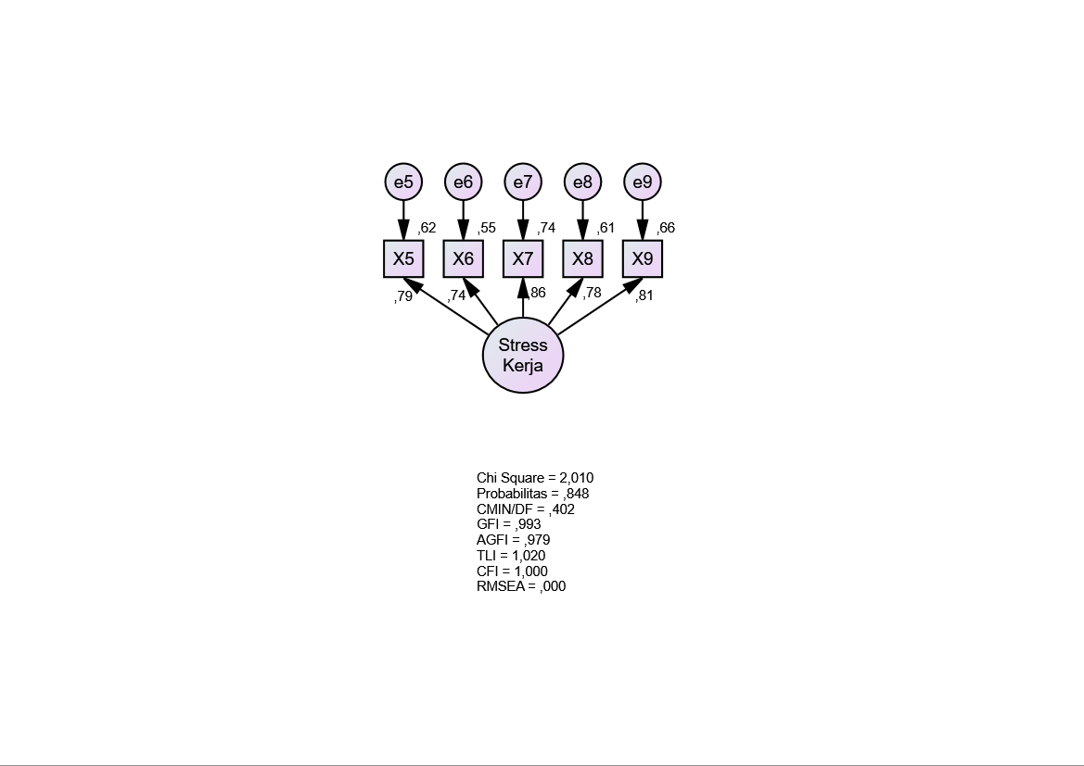

Regression Weights: (Group number 1 - Default model)
 |  |  | Estimate | S.E. | C.R. | P | Label
X5 | <--- | Stress_Kerja | 1,000
X6 | <--- | Stress_Kerja | 1,008 | ,124 | 8,109 | *** | par_1
X7 | <--- | Stress_Kerja | 1,125 | ,116 | 9,698 | *** | par_2
X8 | <--- | Stress_Kerja | 1,002 | ,115 | 8,678 | *** | par_3
X9 | <--- | Stress_Kerja | ,958 | ,105 | 9,094 | *** | par_4

Standardized Regression Weights: (Group number 1 - Default model)
 |  |  | Estimate
X5 | <--- | Stress_Kerja | ,787
X6 | <--- | Stress_Kerja | ,742
X7 | <--- | Stress_Kerja | ,860
X8 | <--- | Stress_Kerja | ,782
X9 | <--- | Stress_Kerja | ,810

Model Fit Summary

CMIN
Model | NPAR | CMIN | DF | P | CMIN/DF
Default model | 10 | 2,010 | 5 | ,848 | ,402
Saturated model | 15 | ,000 | 0
Independence model | 5 | 310,283 | 10 | ,000 | 31,028

RMR, GFI
Model | RMR | GFI | AGFI | PGFI
Default model | ,061 | ,993 | ,979 | ,331
Saturated model | ,000 | 1,000
Independence model | 2,375 | ,383 | ,074 | ,255

Baseline Comparisons
Model | NFI  Delta1 | RFI  rho1 | IFI  Delta2 | TLI  rho2 | CFI
Default model | ,994 | ,987 | 1,010 | 1,020 | 1,000
Saturated model | 1,000 |  | 1,000 |  | 1,000
Independence model | ,000 | ,000 | ,000 | ,000 | ,000

Parsimony-Adjusted Measures
Model | PRATIO | PNFI | PCFI
Default model | ,500 | ,497 | ,500
Saturated model | ,000 | ,000 | ,000
Independence model | 1,000 | ,000 | ,000

NCP
Model | NCP | LO 90 | HI 90
Default model | ,000 | ,000 | 3,000
Saturated model | ,000 | ,000 | ,000
Independence model | 300,283 | 246,466 | 361,522

FMIN
Model | FMIN | F0 | LO 90 | HI 90
Default model | ,018 | ,000 | ,000 | ,027
Saturated model | ,000 | ,000 | ,000 | ,000
Independence model | 2,821 | 2,730 | 2,241 | 3,287

RMSEA
Model | RMSEA | LO 90 | HI 90 | PCLOSE
Default model | ,000 | ,000 | ,074 | ,908
Independence model | ,522 | ,473 | ,573 | ,000

AIC
Model | AIC | BCC | BIC | CAIC
Default model | 22,010 | 23,164 | 49,106 | 59,106
Saturated model | 30,000 | 31,731 | 70,643 | 85,643
Independence model | 320,283 | 320,860 | 333,830 | 338,830

ECVI
Model | ECVI | LO 90 | HI 90 | MECVI
Default model | ,200 | ,227 | ,255 | ,211
Saturated model | ,273 | ,273 | ,273 | ,288
Independence model | 2,912 | 2,422 | 3,468 | 2,917

HOELTER
Model | HOELTER  .05 | HOELTER  .01
Default model | 606 | 826
Independence model | 7 | 9

Konfirmatori Burnout
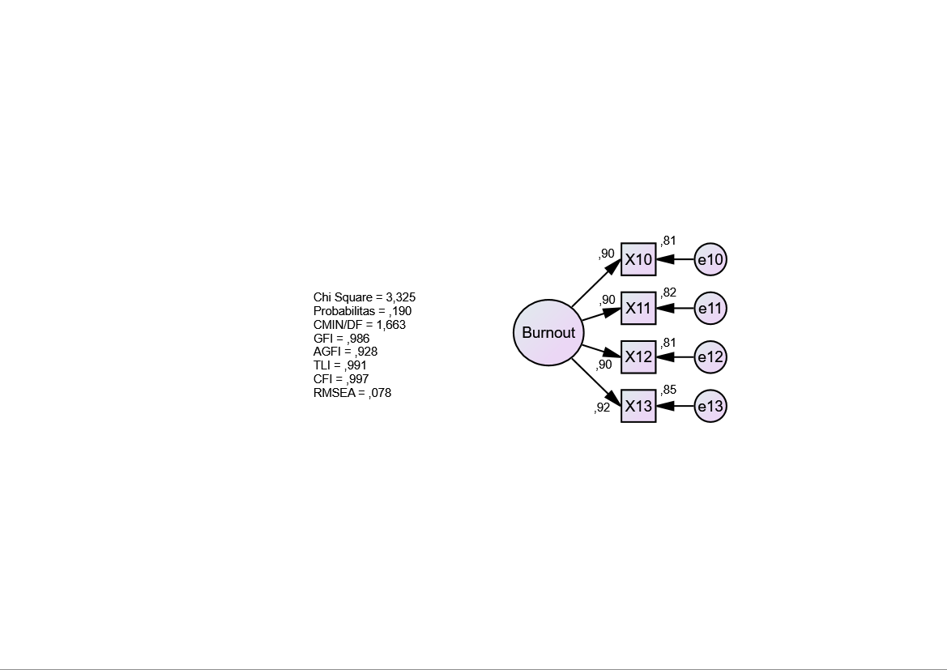

Regression Weights: (Group number 1 - Default model)
 |  |  | Estimate | S.E. | C.R. | P | Label
X10 | <--- | Burnout | 1,000
X11 | <--- | Burnout | 1,159 | ,079 | 14,722 | *** | par_1
X12 | <--- | Burnout | 1,079 | ,074 | 14,498 | *** | par_2
X13 | <--- | Burnout | 1,142 | ,074 | 15,526 | *** | par_3

Standardized Regression Weights: (Group number 1 - Default model)
 |  |  | Estimate
X10 | <--- | Burnout | ,900
X11 | <--- | Burnout | ,904
X12 | <--- | Burnout | ,901
X13 | <--- | Burnout | ,920

Model Fit Summary

CMIN
Model | NPAR | CMIN | DF | P | CMIN/DF
Default model | 8 | 3,325 | 2 | ,190 | 1,663
Saturated model | 10 | ,000 | 0
Independence model | 4 | 435,599 | 6 | ,000 | 72,600

RMR, GFI
Model | RMR | GFI | AGFI | PGFI
Default model | ,048 | ,986 | ,928 | ,197
Saturated model | ,000 | 1,000
Independence model | 3,171 | ,331 | -,115 | ,198

Baseline Comparisons
Model | NFI  Delta1 | RFI  rho1 | IFI  Delta2 | TLI  rho2 | CFI
Default model | ,992 | ,977 | ,997 | ,991 | ,997
Saturated model | 1,000 |  | 1,000 |  | 1,000
Independence model | ,000 | ,000 | ,000 | ,000 | ,000

Parsimony-Adjusted Measures
Model | PRATIO | PNFI | PCFI
Default model | ,333 | ,331 | ,332
Saturated model | ,000 | ,000 | ,000
Independence model | 1,000 | ,000 | ,000

NCP
Model | NCP | LO 90 | HI 90
Default model | 1,325 | ,000 | 10,624
Saturated model | ,000 | ,000 | ,000
Independence model | 429,599 | 364,837 | 501,769

FMIN
Model | FMIN | F0 | LO 90 | HI 90
Default model | ,030 | ,012 | ,000 | ,097
Saturated model | ,000 | ,000 | ,000 | ,000
Independence model | 3,960 | 3,905 | 3,317 | 4,562

RMSEA
Model | RMSEA | LO 90 | HI 90 | PCLOSE
Default model | ,078 | ,000 | ,220 | ,274
Independence model | ,807 | ,743 | ,872 | ,000

AIC
Model | AIC | BCC | BIC | CAIC
Default model | 19,325 | 20,087 | 41,002 | 49,002
Saturated model | 20,000 | 20,952 | 47,095 | 57,095
Independence model | 443,599 | 443,980 | 454,437 | 458,437

ECVI
Model | ECVI | LO 90 | HI 90 | MECVI
Default model | ,176 | ,164 | ,260 | ,183
Saturated model | ,182 | ,182 | ,182 | ,190
Independence model | 4,033 | 3,444 | 4,689 | 4,036

HOELTER
Model | HOELTER  .05 | HOELTER  .01
Default model | 199 | 305
Independence model | 4 | 5

Full Model
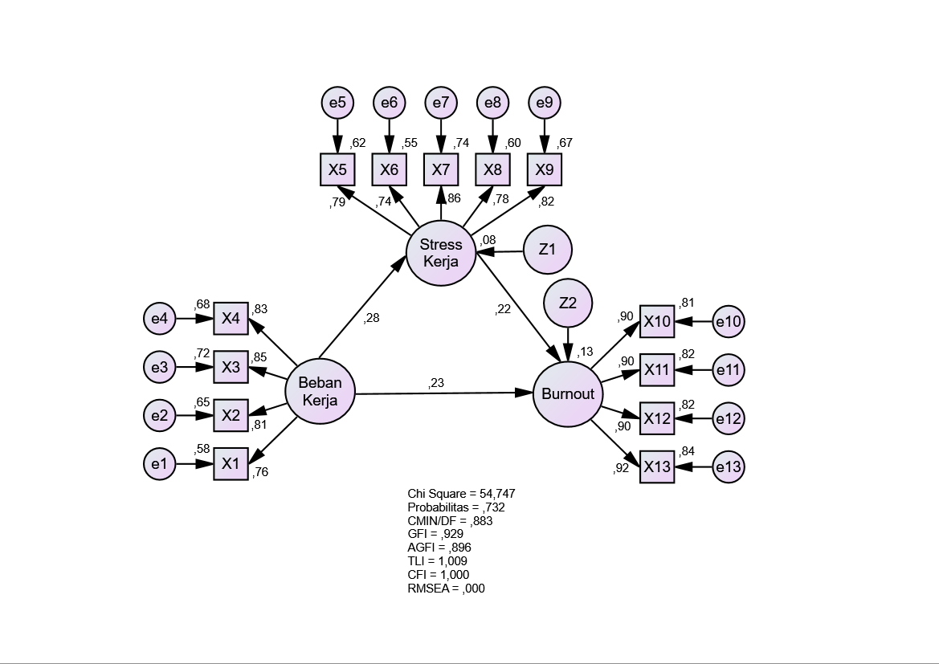

Notes for Group (Group number 1)
The model is recursive.
Sample size = 111

Variable Summary (Group number 1)

Your model contains the following variables (Group number 1)
Observed, endogenous variables
X1
X2
X3
X4
X5
X6
X7
X8
X9
X10
X11
X12
X13
Unobserved, endogenous variables
Stress_Kerja
Burnout
Unobserved, exogenous variables
Beban_Kerja
e1
e2
e3
e4
e5
e6
e7
e8
e9
Z1
e10
e11
e12
e13
Z2

Variable counts (Group number 1)
Number of variables in your model: | 31
Number of observed variables: | 13
Number of unobserved variables: | 18
Number of exogenous variables: | 16
Number of endogenous variables: | 15

Parameter Summary (Group number 1)
 | Weights | Covariances | Variances | Means | Intercepts | Total
Fixed | 18 | 0 | 0 | 0 | 0 | 18
Labeled | 0 | 0 | 0 | 0 | 0 | 0
Unlabeled | 13 | 0 | 16 | 0 | 0 | 29
Total | 31 | 0 | 16 | 0 | 0 | 47

Assessment of normality (Group number 1)
Variable | min | max | skew | c.r. | kurtosis | c.r.
X13 | 1,000 | 10,000 | -,207 | -,892 | -,995 | -2,140
X12 | 1,000 | 10,000 | -,166 | -,712 | -,909 | -1,954
X11 | 1,000 | 10,000 | -,234 | -1,007 | -,934 | -2,008
X10 | 1,000 | 10,000 | ,021 | ,092 | -,923 | -1,985
X9 | 1,000 | 10,000 | -,113 | -,486 | -,362 | -,778
X8 | 1,000 | 10,000 | ,249 | 1,070 | -,555 | -1,194
X7 | 1,000 | 10,000 | ,017 | ,075 | -,782 | -1,682
X6 | 1,000 | 10,000 | ,104 | ,447 | -,466 | -1,002
X5 | 1,000 | 10,000 | ,043 | ,186 | -,354 | -,762
X4 | 1,000 | 10,000 | ,614 | 2,642 | ,222 | ,477
X3 | 1,000 | 10,000 | ,413 | 1,778 | -,535 | -1,150
X2 | 1,000 | 10,000 | ,250 | 1,074 | -,358 | -,770
X1 | 1,000 | 10,000 | ,470 | 2,022 | -,338 | -,726
Multivariate |  |  |  |  | 3,191 | ,851

Observations farthest from the centroid (Mahalanobis distance) (Group number 1)
Observation number | Mahalanobis d-squared | p1 | p2
70 | 29,146 | ,006 | ,501
37 | 25,641 | ,019 | ,625
98 | 25,603 | ,019 | ,359
4 | 24,199 | ,029 | ,411
25 | 22,668 | ,046 | ,579
16 | 22,482 | ,048 | ,449
63 | 21,746 | ,059 | ,491
20 | 21,330 | ,067 | ,463
91 | 21,237 | ,068 | ,348
27 | 20,839 | ,076 | ,338
69 | 20,668 | ,080 | ,271
89 | 20,364 | ,086 | ,252
36 | 19,674 | ,104 | ,364
85 | 19,277 | ,115 | ,396
18 | 19,184 | ,118 | ,323
38 | 19,098 | ,120 | ,256
109 | 18,586 | ,136 | ,344
24 | 18,455 | ,141 | ,299
90 | 18,440 | ,142 | ,219
105 | 17,768 | ,167 | ,388
110 | 17,760 | ,167 | ,300
111 | 17,685 | ,170 | ,247
17 | 17,685 | ,170 | ,177
71 | 17,435 | ,180 | ,192
44 | 17,202 | ,190 | ,204
35 | 16,825 | ,207 | ,276
74 | 16,822 | ,208 | ,207
88 | 16,123 | ,243 | ,442
46 | 16,035 | ,247 | ,401
1 | 15,539 | ,275 | ,580
10 | 15,436 | ,281 | ,551
97 | 15,249 | ,292 | ,571
94 | 14,950 | ,310 | ,652
3 | 14,686 | ,327 | ,714
47 | 14,454 | ,343 | ,758
31 | 14,293 | ,354 | ,770
75 | 14,077 | ,368 | ,806
93 | 14,016 | ,373 | ,775
2 | 13,972 | ,376 | ,734
19 | 13,929 | ,379 | ,689
15 | 13,662 | ,398 | ,761
29 | 13,408 | ,417 | ,820
32 | 13,395 | ,418 | ,771
54 | 13,149 | ,436 | ,828
78 | 13,101 | ,440 | ,797
52 | 13,051 | ,444 | ,764
62 | 12,954 | ,451 | ,753
28 | 12,879 | ,457 | ,731
40 | 12,768 | ,466 | ,729
56 | 12,740 | ,468 | ,679
104 | 12,611 | ,478 | ,688
59 | 12,562 | ,482 | ,649
45 | 12,557 | ,483 | ,580
103 | 12,229 | ,509 | ,715
73 | 12,182 | ,513 | ,677
49 | 12,143 | ,516 | ,632
22 | 12,117 | ,518 | ,576
60 | 11,958 | ,531 | ,609
12 | 11,915 | ,535 | ,564
61 | 11,866 | ,539 | ,523
76 | 11,756 | ,548 | ,524
30 | 11,684 | ,554 | ,499
11 | 11,684 | ,554 | ,423
99 | 11,502 | ,569 | ,474
26 | 11,475 | ,571 | ,418
42 | 11,437 | ,574 | ,369
50 | 11,254 | ,590 | ,421
9 | 11,237 | ,591 | ,359
67 | 10,991 | ,612 | ,455
96 | 10,880 | ,621 | ,457
33 | 10,822 | ,626 | ,422
5 | 10,665 | ,639 | ,458
87 | 10,472 | ,655 | ,520
102 | 10,416 | ,660 | ,482
48 | 10,231 | ,675 | ,539
92 | 10,120 | ,684 | ,540
13 | 10,111 | ,685 | ,465
57 | 10,103 | ,685 | ,391
53 | 9,787 | ,711 | ,543
65 | 9,765 | ,713 | ,477
84 | 9,696 | ,719 | ,444
86 | 9,695 | ,719 | ,363
83 | 9,662 | ,721 | ,307
95 | 9,497 | ,734 | ,341
6 | 9,352 | ,746 | ,361
81 | 9,058 | ,769 | ,491
39 | 8,988 | ,774 | ,454
51 | 8,947 | ,777 | ,394
79 | 8,942 | ,777 | ,312
23 | 8,329 | ,822 | ,670
101 | 8,201 | ,830 | ,671
8 | 8,149 | ,834 | ,615
43 | 7,888 | ,851 | ,706
68 | 7,869 | ,852 | ,624
66 | 7,815 | ,855 | ,561
41 | 7,806 | ,856 | ,461
107 | 7,701 | ,862 | ,429
80 | 7,442 | ,878 | ,509
55 | 7,274 | ,887 | ,517
58 | 7,162 | ,894 | ,478

Sample Moments (Group number 1)

Sample Covariances (Group number 1)
 | X13 | X12 | X11 | X10 | X9 | X8 | X7 | X6 | X5 | X4 | X3
X13 | 5,255
X12 | 4,212 | 4,890
X11 | 4,437 | 4,344 | 5,607
X10 | 3,953 | 3,595 | 3,962 | 4,207
X9 | 1,166 | 1,335 | 1,530 | 1,333 | 3,917
X8 | ,814 | 1,047 | ,786 | ,884 | 2,719 | 4,598
X7 | ,884 | 1,312 | 1,264 | ,929 | 3,030 | 3,076 | 4,786
X6 | ,236 | ,846 | ,575 | ,528 | 2,559 | 2,940 | 3,260 | 5,172
X5 | ,501 | ,962 | 1,137 | ,898 | 2,731 | 2,804 | 3,141 | 2,756 | 4,518
X4 | 1,044 | 1,189 | 1,193 | ,938 | 1,396 | ,771 | 1,361 | 1,309 | 1,072 | 4,573
X3 | 1,172 | 1,384 | 1,282 | 1,142 | ,877 | ,274 | ,849 | ,611 | ,606 | 3,199 | 4,702
X2 | ,778 | ,909 | ,940 | ,719 | ,830 | ,602 | 1,088 | 1,187 | 1,038 | 3,034 | 3,127
X1 | ,925 | ,869 | ,720 | ,723 | ,446 | ,002 | ,558 | ,424 | ,355 | 2,609 | 2,792

 | X2 | X1
X2 | 4,430
X1 | 2,472 | 3,739
Condition number = 38,002
Eigenvalues
23,795 12,737 10,423 2,209 1,864 1,700 1,538 1,391 1,317 1,144 ,866 ,784 ,626
Determinant of sample covariance matrix = 30270,861

Sample Correlations (Group number 1)
 | X13 | X12 | X11 | X10 | X9 | X8 | X7 | X6 | X5 | X4 | X3
X13 | 1,000
X12 | ,831 | 1,000
X11 | ,817 | ,830 | 1,000
X10 | ,841 | ,793 | ,816 | 1,000
X9 | ,257 | ,305 | ,326 | ,328 | 1,000
X8 | ,166 | ,221 | ,155 | ,201 | ,641 | 1,000
X7 | ,176 | ,271 | ,244 | ,207 | ,700 | ,656 | 1,000
X6 | ,045 | ,168 | ,107 | ,113 | ,569 | ,603 | ,655 | 1,000
X5 | ,103 | ,205 | ,226 | ,206 | ,649 | ,615 | ,675 | ,570 | 1,000
X4 | ,213 | ,252 | ,236 | ,214 | ,330 | ,168 | ,291 | ,269 | ,236 | 1,000
X3 | ,236 | ,289 | ,250 | ,257 | ,204 | ,059 | ,179 | ,124 | ,132 | ,690 | 1,000
X2 | ,161 | ,195 | ,189 | ,167 | ,199 | ,133 | ,236 | ,248 | ,232 | ,674 | ,685
X1 | ,209 | ,203 | ,157 | ,182 | ,117 | ,000 | ,132 | ,096 | ,086 | ,631 | ,666

 | X2 | X1
X2 | 1,000
X1 | ,607 | 1,000

Condition number = 39,317
Eigenvalues
5,070 2,651 2,339 ,458 ,412 ,380 ,376 ,301 ,281 ,263 ,189 ,152 ,129

Notes for Model (Default model)

Computation of degrees of freedom (Default model)
Number of distinct sample moments: | 91
Number of distinct parameters to be estimated: | 29
Degrees of freedom (91 - 29): | 62

Result (Default model)
Minimum was achieved
Chi-square = 54,747
Degrees of freedom = 62
Probability level = ,732

Estimates (Group number 1 - Default model)

Scalar Estimates (Group number 1 - Default model)

Maximum Likelihood Estimates

Regression Weights: (Group number 1 - Default model)
 |  |  | Estimate | S.E. | C.R. | P | Label
Stress_Kerja | <--- | Beban_Kerja | ,315 | ,123 | 2,561 | ,010 | par_8
Burnout | <--- | Stress_Kerja | ,244 | ,115 | 2,121 | ,034 | par_12
Burnout | <--- | Beban_Kerja | ,289 | ,131 | 2,208 | ,027 | par_13
X1 | <--- | Beban_Kerja | 1,000
X2 | <--- | Beban_Kerja | 1,148 | ,135 | 8,516 | *** | par_1
X3 | <--- | Beban_Kerja | 1,244 | ,137 | 9,092 | *** | par_2
X4 | <--- | Beban_Kerja | 1,196 | ,137 | 8,750 | *** | par_3
X5 | <--- | Stress_Kerja | 1,000
X6 | <--- | Stress_Kerja | 1,005 | ,125 | 8,073 | *** | par_4
X7 | <--- | Stress_Kerja | 1,128 | ,116 | 9,716 | *** | par_5
X8 | <--- | Stress_Kerja | ,998 | ,116 | 8,628 | *** | par_6
X9 | <--- | Stress_Kerja | ,966 | ,105 | 9,161 | *** | par_7
X10 | <--- | Burnout | 1,000
X11 | <--- | Burnout | 1,161 | ,079 | 14,753 | *** | par_9
X12 | <--- | Burnout | 1,082 | ,074 | 14,556 | *** | par_10
X13 | <--- | Burnout | 1,140 | ,074 | 15,439 | *** | par_11

Standardized Regression Weights: (Group number 1 - Default model)
 |  |  | Estimate
Stress_Kerja | <--- | Beban_Kerja | ,279
Burnout | <--- | Stress_Kerja | ,221
Burnout | <--- | Beban_Kerja | ,232
X1 | <--- | Beban_Kerja | ,765
X2 | <--- | Beban_Kerja | ,807
X3 | <--- | Beban_Kerja | ,848
X4 | <--- | Beban_Kerja | ,827
X5 | <--- | Stress_Kerja | ,786
X6 | <--- | Stress_Kerja | ,738
X7 | <--- | Stress_Kerja | ,861
X8 | <--- | Stress_Kerja | ,777
X9 | <--- | Stress_Kerja | ,816
X10 | <--- | Burnout | ,900
X11 | <--- | Burnout | ,905
X12 | <--- | Burnout | ,903
X13 | <--- | Burnout | ,918

Variances: (Group number 1 - Default model)
 |  |  | Estimate | S.E. | C.R. | P | Label
Beban_Kerja |  |  | 2,187 | ,481 | 4,544 | *** | par_14
Z1 |  |  | 2,573 | ,546 | 4,717 | *** | par_15
Z2 |  |  | 2,960 | ,499 | 5,936 | *** | par_16
e1 |  |  | 1,552 | ,255 | 6,086 | *** | par_17
e2 |  |  | 1,547 | ,274 | 5,637 | *** | par_18
e3 |  |  | 1,320 | ,269 | 4,906 | *** | par_19
e4 |  |  | 1,443 | ,274 | 5,267 | *** | par_20
e5 |  |  | 1,727 | ,283 | 6,094 | *** | par_21
e6 |  |  | 2,352 | ,366 | 6,427 | *** | par_22
e7 |  |  | 1,237 | ,246 | 5,032 | *** | par_23
e8 |  |  | 1,820 | ,296 | 6,144 | *** | par_24
e9 |  |  | 1,311 | ,228 | 5,749 | *** | par_25
e10 |  |  | ,800 | ,143 | 5,607 | *** | par_26
e11 |  |  | 1,019 | ,186 | 5,486 | *** | par_27
e12 |  |  | ,904 | ,163 | 5,532 | *** | par_28
e13 |  |  | ,829 | ,161 | 5,143 | *** | par_29

Squared Multiple Correlations: (Group number 1 - Default model)
 |  |  | Estimate
Stress_Kerja |  |  | ,078
Burnout |  |  | ,131
X13 |  |  | ,842
X12 |  |  | ,815
X11 |  |  | ,818
X10 |  |  | ,810
X9 |  |  | ,665
X8 |  |  | ,604
X7 |  |  | ,742
X6 |  |  | ,545
X5 |  |  | ,618
X4 |  |  | ,685
X3 |  |  | ,719
X2 |  |  | ,651
X1 |  |  | ,585

Standardized Residual Covariances (Group number 1 - Default model)
 | X13 | X12 | X11 | X10 | X9 | X8 | X7 | X6 | X5 | X4 | X3
X13 | ,000
X12 | ,019 | ,000
X11 | -,103 | ,104 | ,000
X10 | ,121 | -,162 | ,014 | ,000
X9 | ,442 | ,971 | 1,186 | 1,217 | ,000
X8 | -,393 | ,208 | -,474 | ,011 | ,058 | ,000
X7 | -,507 | ,502 | ,220 | -,148 | -,022 | -,119 | ,000
X6 | -1,527 | -,229 | -,867 | -,790 | -,303 | ,264 | ,171 | ,000
X5 | -1,062 | ,020 | ,233 | ,041 | ,072 | ,038 | -,012 | -,092 | ,000
X4 | -,100 | ,331 | ,163 | -,047 | 1,459 | -,117 | ,947 | 1,021 | ,562 | ,000
X3 | ,076 | ,654 | ,251 | ,336 | ,117 | -1,289 | -,255 | -,525 | -,562 | -,102 | ,000
X2 | -,575 | -,190 | -,262 | -,478 | ,161 | -,429 | ,437 | ,847 | ,569 | ,057 | ,008
X1 | ,026 | ,006 | -,471 | -,201 | -,594 | -1,712 | -,535 | -,634 | -,840 | -,015 | ,152

 | X2 | X1
X2 | ,000
X1 | -,085 | ,000

Factor Score Weights (Group number 1 - Default model)
 | X13 | X12 | X11 | X10 | X9 | X8 | X7 | X6 | X5 | X4 | X3 | X2 | X1
Beban_Kerja | ,006 | ,005 | ,005 | ,005 | ,005 | ,004 | ,006 | ,003 | ,004 | ,198 | ,225 | ,178 | ,154
Stress_Kerja | ,005 | ,005 | ,005 | ,005 | ,199 | ,148 | ,246 | ,115 | ,156 | ,005 | ,006 | ,005 | ,004
Burnout | ,238 | ,208 | ,197 | ,217 | ,003 | ,002 | ,004 | ,002 | ,002 | ,003 | ,004 | ,003 | ,003

Standardized Total Effects (Group number 1 - Default model)
 | Beban_Kerja | Stress_Kerja | Burnout
Stress_Kerja | ,279 | ,000 | ,000
Burnout | ,294 | ,221 | ,000
X13 | ,269 | ,203 | ,918
X12 | ,265 | ,200 | ,903
X11 | ,265 | ,200 | ,905
X10 | ,264 | ,199 | ,900
X9 | ,228 | ,816 | ,000
X8 | ,217 | ,777 | ,000
X7 | ,240 | ,861 | ,000
X6 | ,206 | ,738 | ,000
X5 | ,219 | ,786 | ,000
X4 | ,827 | ,000 | ,000
X3 | ,848 | ,000 | ,000
X2 | ,807 | ,000 | ,000
X1 | ,765 | ,000 | ,000

Standardized Direct Effects (Group number 1 - Default model)
 | Beban_Kerja | Stress_Kerja | Burnout
Stress_Kerja | ,279 | ,000 | ,000
Burnout | ,232 | ,221 | ,000
X13 | ,000 | ,000 | ,918
X12 | ,000 | ,000 | ,903
X11 | ,000 | ,000 | ,905
X10 | ,000 | ,000 | ,900
X9 | ,000 | ,816 | ,000
X8 | ,000 | ,777 | ,000
X7 | ,000 | ,861 | ,000
X6 | ,000 | ,738 | ,000
X5 | ,000 | ,786 | ,000
X4 | ,827 | ,000 | ,000
X3 | ,848 | ,000 | ,000
X2 | ,807 | ,000 | ,000
X1 | ,765 | ,000 | ,000

Standardized Indirect Effects (Group number 1 - Default model)
 | Beban_Kerja | Stress_Kerja | Burnout
Stress_Kerja | ,000 | ,000 | ,000
Burnout | ,062 | ,000 | ,000
X13 | ,269 | ,203 | ,000
X12 | ,265 | ,200 | ,000
X11 | ,265 | ,200 | ,000
X10 | ,264 | ,199 | ,000
X9 | ,228 | ,000 | ,000
X8 | ,217 | ,000 | ,000
X7 | ,240 | ,000 | ,000
X6 | ,206 | ,000 | ,000
X5 | ,219 | ,000 | ,000
X4 | ,000 | ,000 | ,000
X3 | ,000 | ,000 | ,000
X2 | ,000 | ,000 | ,000
X1 | ,000 | ,000 | ,000

Modification Indices (Group number 1 - Default model)

Covariances: (Group number 1 - Default model)
 |  |  | M.I. | Par Change
e8 | <--> | e11 | 4,098 | -,324
e5 | <--> | e13 | 4,023 | -,292
e4 | <--> | Z1 | 4,262 | ,460

Variances: (Group number 1 - Default model)
 |  |  | M.I. | Par Change

Regression Weights: (Group number 1 - Default model)
 |  |  | M.I. | Par Change
X13 | <--- | X6 | 4,255 | -,092
X13 | <--- | X5 | 6,408 | -,121
X9 | <--- | X11 | 4,239 | ,106
X9 | <--- | X10 | 4,810 | ,130
X4 | <--- | X9 | 5,425 | ,154

Model Fit Summary

CMIN
Model | NPAR | CMIN | DF | P | CMIN/DF
Default model | 29 | 54,747 | 62 | ,732 | ,883
Saturated model | 91 | ,000 | 0
Independence model | 13 | 1052,969 | 78 | ,000 | 13,500

RMR, GFI
Model | RMR | GFI | AGFI | PGFI
Default model | ,234 | ,929 | ,896 | ,633
Saturated model | ,000 | 1,000
Independence model | 1,775 | ,332 | ,220 | ,284

Baseline Comparisons
Model | NFI  Delta1 | RFI  rho1 | IFI  Delta2 | TLI  rho2 | CFI
Default model | ,948 | ,935 | 1,007 | 1,009 | 1,000
Saturated model | 1,000 |  | 1,000 |  | 1,000
Independence model | ,000 | ,000 | ,000 | ,000 | ,000

Parsimony-Adjusted Measures
Model | PRATIO | PNFI | PCFI
Default model | ,795 | ,754 | ,795
Saturated model | ,000 | ,000 | ,000
Independence model | 1,000 | ,000 | ,000

NCP
Model | NCP | LO 90 | HI 90
Default model | ,000 | ,000 | 13,246
Saturated model | ,000 | ,000 | ,000
Independence model | 974,969 | 873,886 | 1083,473

FMIN
Model | FMIN | F0 | LO 90 | HI 90
Default model | ,498 | ,000 | ,000 | ,120
Saturated model | ,000 | ,000 | ,000 | ,000
Independence model | 9,572 | 8,863 | 7,944 | 9,850

RMSEA
Model | RMSEA | LO 90 | HI 90 | PCLOSE
Default model | ,000 | ,000 | ,044 | ,972
Independence model | ,337 | ,319 | ,355 | ,000

AIC
Model | AIC | BCC | BIC | CAIC
Default model | 112,747 | 121,205 | 191,323 | 220,323
Saturated model | 182,000 | 208,542 | 428,567 | 519,567
Independence model | 1078,969 | 1082,760 | 1114,193 | 1127,193

ECVI
Model | ECVI | LO 90 | HI 90 | MECVI
Default model | 1,025 | 1,091 | 1,211 | 1,102
Saturated model | 1,655 | 1,655 | 1,655 | 1,896
Independence model | 9,809 | 8,890 | 10,795 | 9,843

HOELTER
Model | HOELTER  .05 | HOELTER  .01
Default model | 164 | 183
Independence model | 11 | 12

